|  |
| --- |
| Technical manual |
| Installation manual |
|  |
| Groep 2: Jean-Pierre / Lukasz / Youssef |
|  |

# Content

## Required product environment

## Required software

## Database setup

## Uploading application files

## Updating config file

### Required product environment

The requirements for the web-application to operate in are as followed:

1. There must be server running with a webserver installed on it with the following requirements:
2. Php version 7.0.0
3. OpenSSL PHP Extension
4. PDO PHP Extension
5. Mbstring PHP Extension
6. Tokenizer PHP Extension
7. XML PHP extention

### Required software

In order to setup up the application we need to have a FTP client installed on the computer on where you want the upload the project from. This is a piece of software that can connect to the file system of a external computer (in this case this will be the webserver).

The program were going to use in this manual will be WinSCP.

The download link for WinSCP: <https://winscp.net/download/WinSCP-5.11.2-Setup.exe>

After you installed the program you can continue to the next instruction.

### Database setup

In order to setup the database we will need to have a SQL file (you will be able to find this file under the name database.sql).

When you found the SQL file we have to login into the database of our host servage.net, in case you haven’t bought this hosting service please proceed and buy it right now!

When everything is right you have been sended additional info with your data on how to get aces to the powerful tool PhpMyAdmin (this is a MySQL interface) and login with your login name and password:

Afterwards you will see a window like this below:

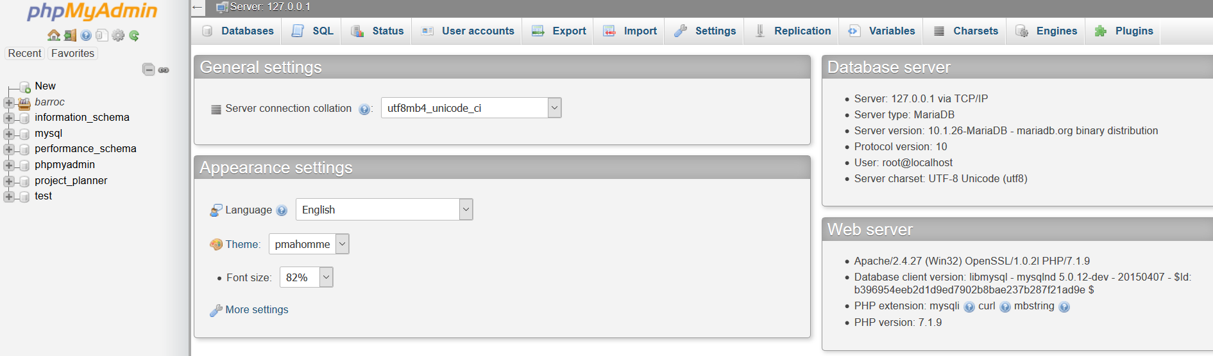

Ones u have the following window in front of you we will be implementing our SQL file to import our database setup.

Click on the button “import” :

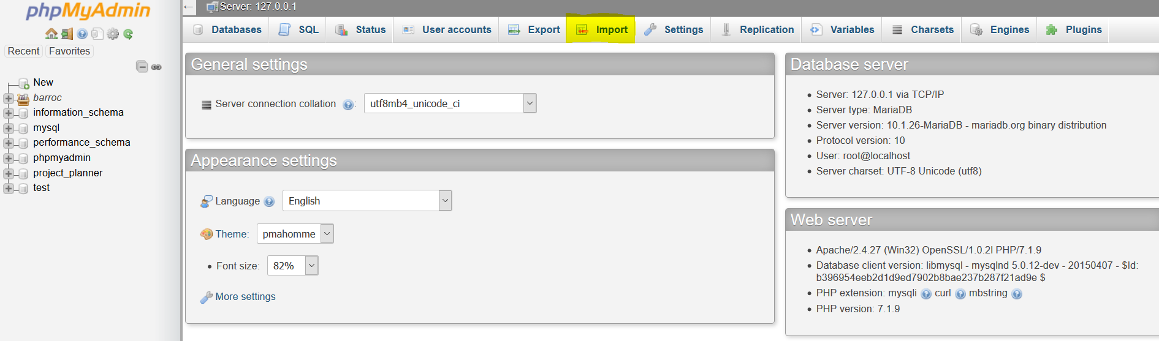

Once u have clicked on that button u will see the following page:

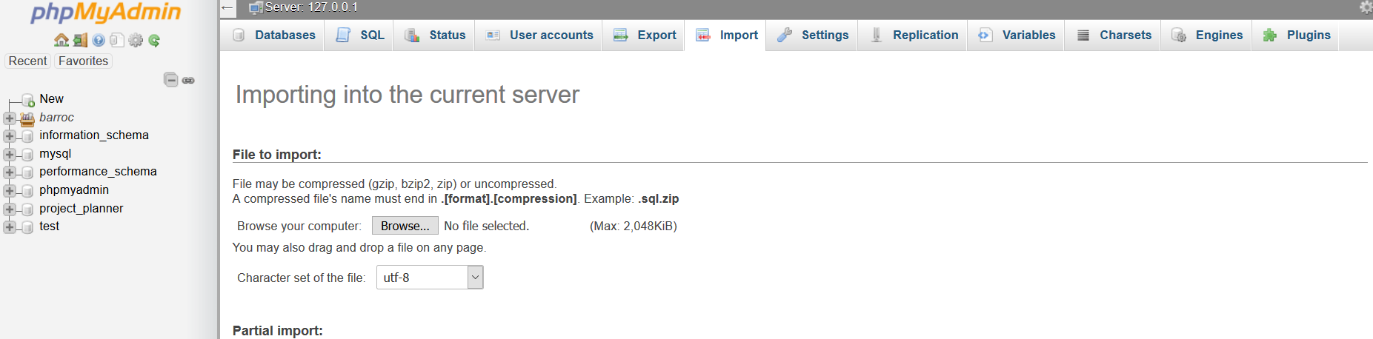

Now we are almost done click on the browse button and select the SQL file from ealyer and click on the button “GO” at the bottom of the page.

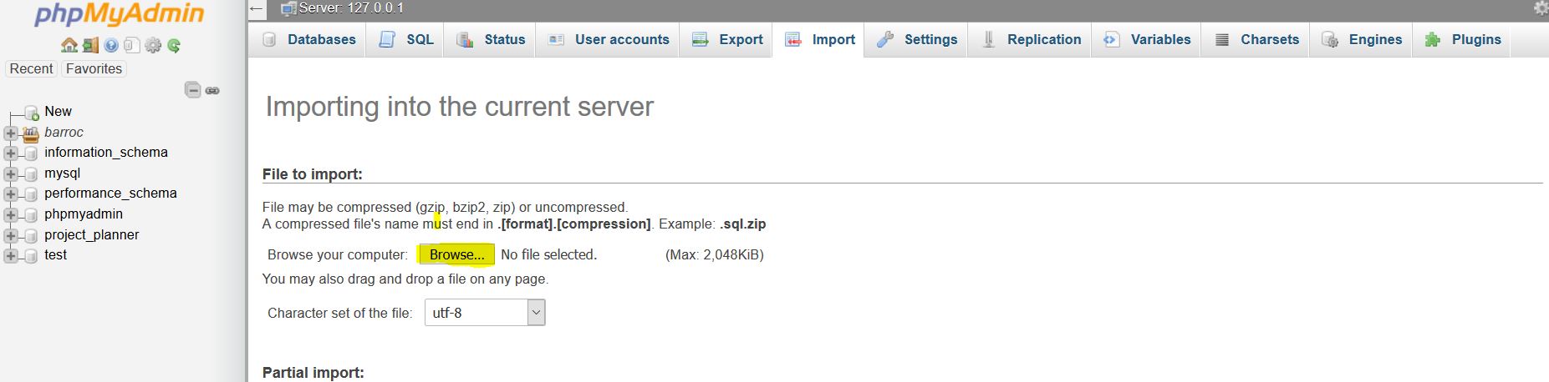

After u clicked “GO” at the bottom of the page de database will be created and we are all set for this part of the installation

### Uploading application files

Now we have the database all done we need to get the actual application set online.

Therefor we’re going to use the application we installed earlier in this manual: WinSCP.

First we open de program: 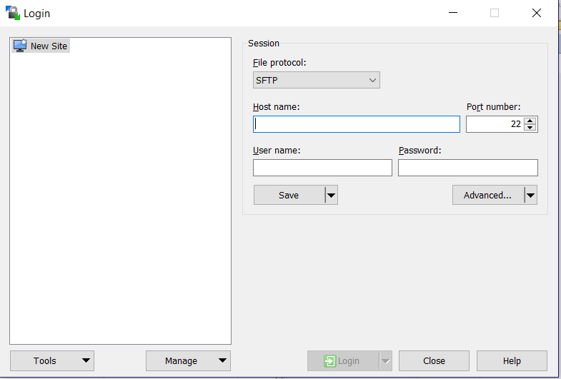

Now we have that done we have to enter our credentials which are provide by servage.net.

Fill those in at “host name”, “port number”, “User name”, “Password” and click on “Login”

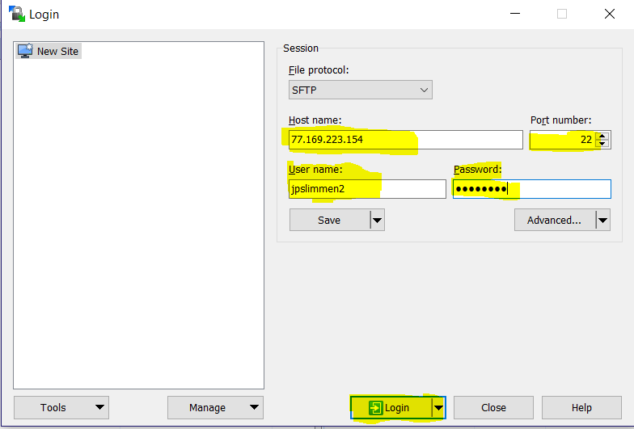

Once we’re logged in you should see a windows similar like this one:

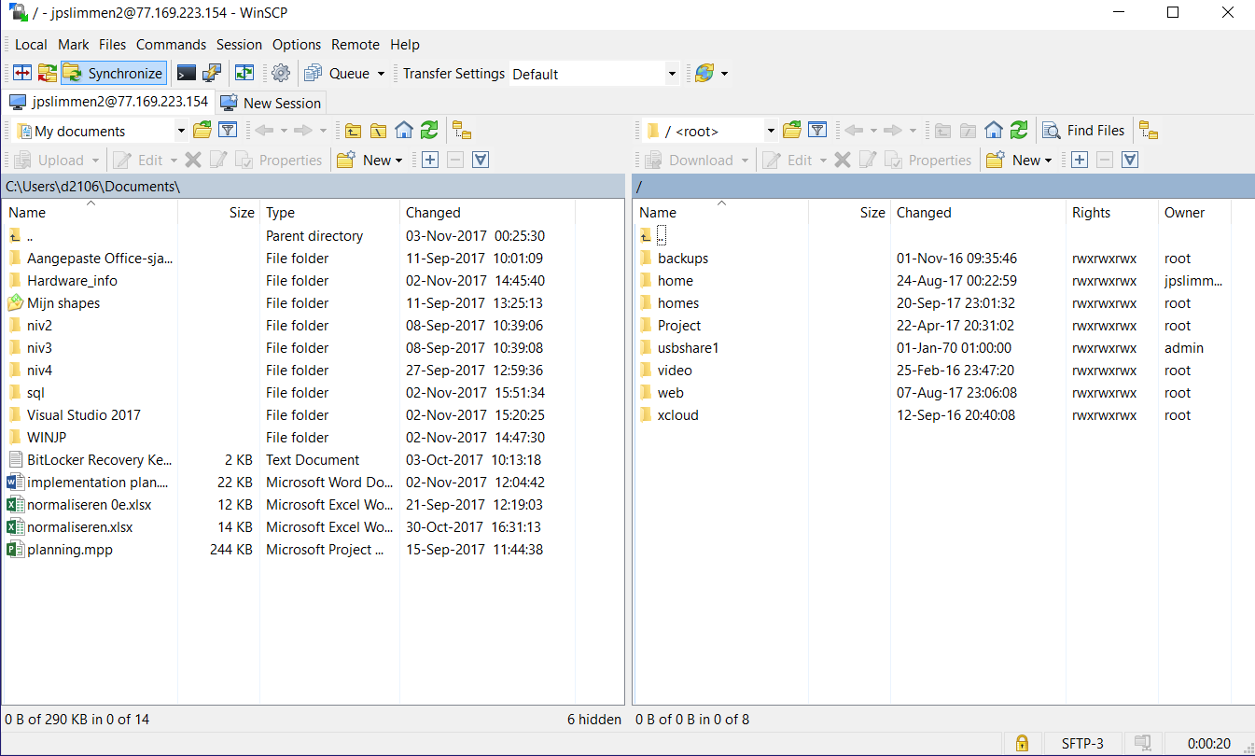

On the left side of this window we see our file system of our own computer and on the right side the file system of the servers file system.

In order to get our application on the server we have to first locate the application on our side:

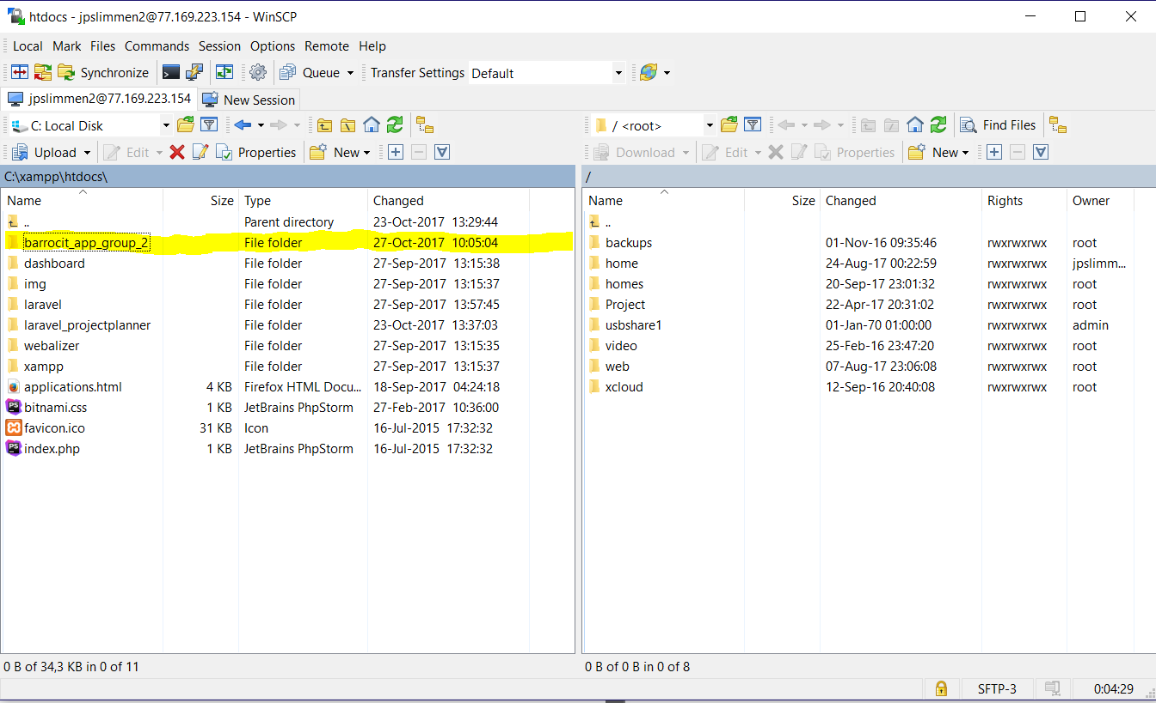

Once we found our application we have to transfer the files within the folder to our web folder on the server side:

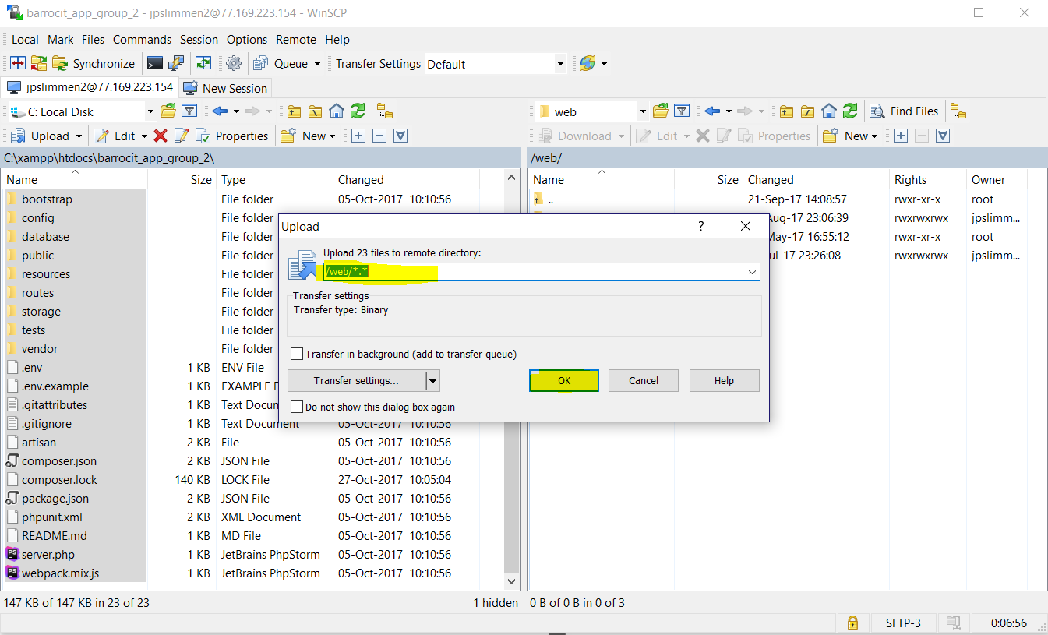

Select all your files and press on upload and the dialog from above will pop-up make sure the destination is set to the web folder and click on “OK”. That all you have to do to setup the application in our online environment.

### Updating config file

At the moment there is no need to update the config file because all settings are already done for while the application was in developing mode.

BUT if have a database running on a different host we will need to change some little things:

1. In the folder were our application is located we need to open the .env file
2. Once you have the file open you should see the following:

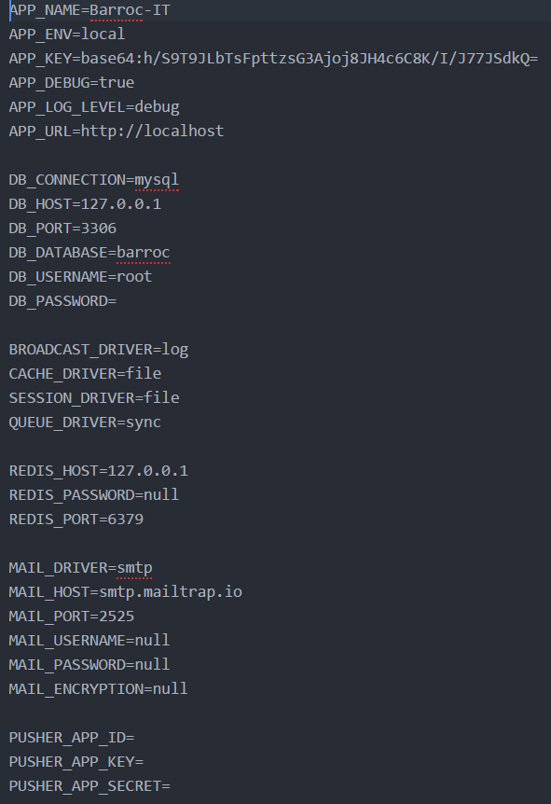

In order to change the destination of the database we need to change the value of “DB_HOST=”

Enter the address of the server provided by you server host

If the username of the database and the password are also different as shown above you should fill the “DB_USERNAME=” with the username provided in this case the username is root and the “DB_PASSWORD=” nothing of this is changed please edit it and save the file this also counts for the “DB_PORT=”. Once done of course save the file and close it when done.

For more info on this document we are available through email or telephone.

This includes the end of the technical manual on setting up the application in a online environment.